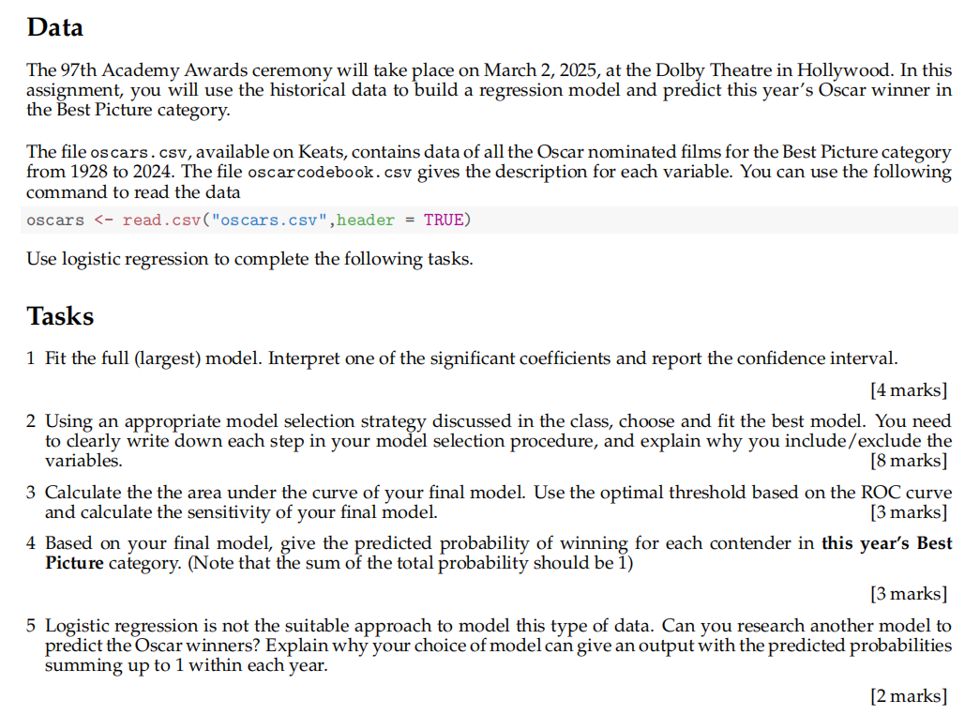

===Q1===

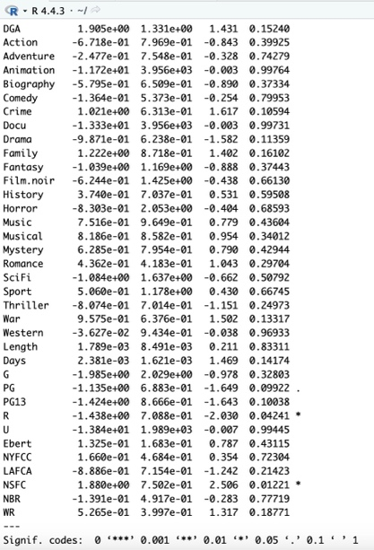
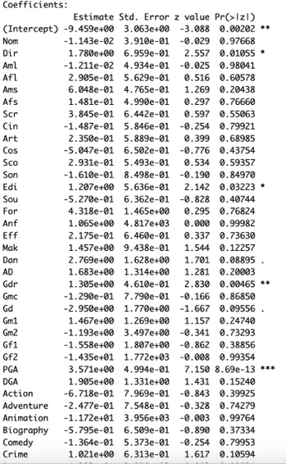
I cleaned the data by excluding entries from the year 2024 (since the results are not yet known), the variable Name (as it is a string and not useful for modelling), and Pic (which contains only 1s and has no variation). The response variable Win_oscar_new_Ch is derived from Ch, and the predictors include variables such as Nom, Dir, Aml, Afl, etc.
Figure 2
The full logistic regression model was fitted using the cleaned dataset. The model output is shown in Figure 2, which displays the estimated coefficients, standard errors, z-values, and p-values for all predictors. Among them, the variable Edi (editing nomination) is statistically significant, with a coefficient of 1.207 and a p-value of 0.03223 (less than 0.05). This provides evidence to reject the null hypothesis and indicates that Edi has a significant positive effect on the odds of winning an Oscar.
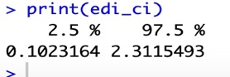
To further interpret the effect, the 95% confidence interval for the coefficient of Edi is shown in Figure 1, ranging from 0.1023164 to 2.3115493. Since the interval does not include zero, the effect is statistically significant. This coefficient implies that a 1-unit increase in Edi increases the log-odds of winning an Oscar by approximately 1.207, which translates to an odds ratio of 3.34 (i.e., exp(1.207)). In other words, receiving one additional editing nomination increases the odds of winning by approximately 234%.
Figure 1

===Q2===
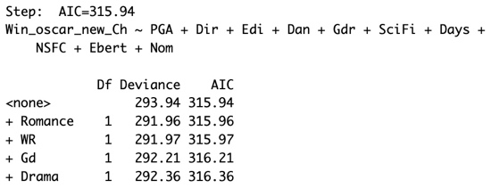
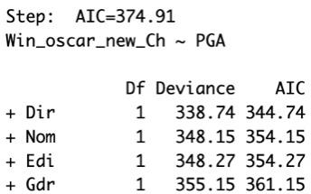
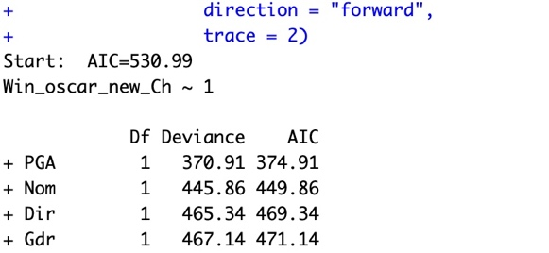
I applied forward stepwise logistic using Akaike Information Criterion (AIC) to select the optimal subset of predictors because AIC has good fit, balances goodness-of-fit, also avoids overfitting by penalizing overly complex models’ variables. Processes start with a null logistic regression model containing only the intercept. Then variables are added one at a time. At each step the algorithm evaluates which single variable, if added, would result in the greatest reduction in AIC. This continues until no further reduction was possible.
Figure 3.3
Figure 3.2
Figure 3.1
Figure 3 shows some of the selection process:
Fig 3.1 shows the initial step, where the null model is evaluated with all candidate variables. `PGA` produces the largest AIC reduction (from 530.99 to 374.91), so it is selected first.
Fig 3.2 displays the next iteration, with `PGA` already in the model. `Dir` offers the next best improvement (to 344.74), so is added in this step. After several iterations
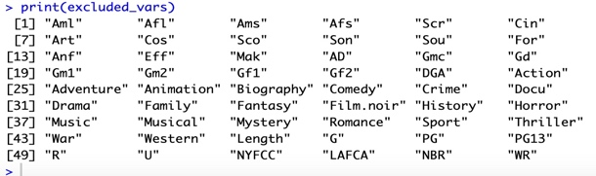
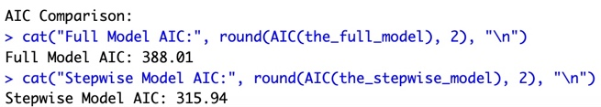
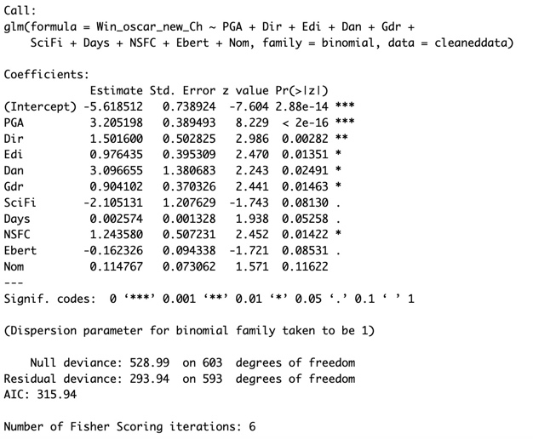
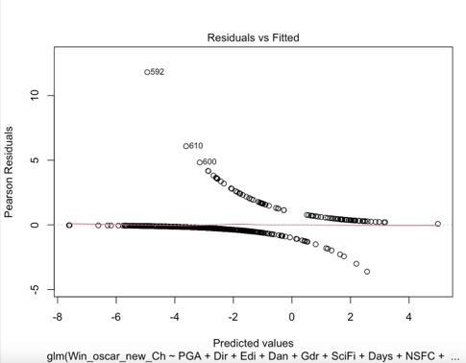
Fig 3.3 shows the final stage of selection: no additional variables can further reduce AIC from 315.94. The process terminates here, yielding the final model. The final selected model includes those variables: ‘PGA’, ‘Dir’, ‘Edi’, ‘Dan’, ‘Gdr’, ‘SciFi’, ‘Days’, ‘NSFC’, ‘Ebert’, and ‘Nom. These variables were selected because they are either significantly reduced the AIC or were statistically meaningful. Variables such as ‘Aml’, ‘Afl’, ‘Art’, ‘PG13’, ‘Drama’, and others shown in Figure 5 were excluded, as they did not meaningfully improve the model based on AIC or had high p-values. I compared AIC between the full model and the stepwise-selected model shown in figure 4, which suggests the full model had an AIC of 388.01, while the final model selected through stepwise selection had an AIC of 315.94, indicating a better fit. Figure 6 shows the summary of the final model, confirming the coefficients and p-values of the selected predictors. Figure 7 shows the residuals vs fitted values plot for the stepwise-selected logistic regression model. The residuals are roughly centred around zero, with no clear pattern, suggesting acceptable model fit
Figure 4
Figure 5
Figure 7
Figure 6

=== Q3 ===
In my coding I generate predicted probabilities from the refined model, I constructed the ROC curve by treating Oscar winners as the positive class (1) and non-winners as the negative class (0), with direction set to “controls < cases”. Then I Visualized the ROC curve (Figure 9) and calculated the Area Under the Curve (AUC). Youden’s Index was used to determine the optimal classification threshold, which was 0.111.
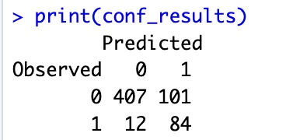
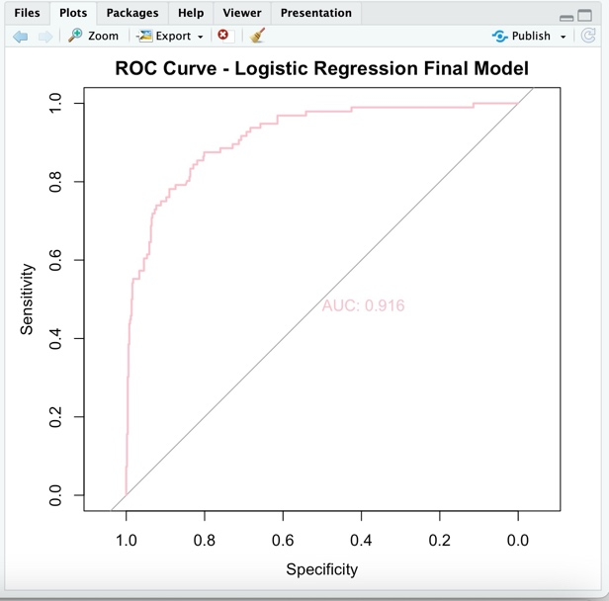
Using this threshold, predicted probabilities were converted into binary classes. A confusion matrix was then constructed (Figure 8), from which sensitivity and specificity were computed. Sensitivity equals 0.875 which means 87.5% of Oscar winners were correctly predicted. Specificity equals 0,801 which means 80.1% of non-winners were correctly predicted.
Figure 8
Those results show that the model performs well in identifying both winners and non-winners. The AUC of 0.916 (Figure 9) further confirms strong overall classification performance in distinguish Oscar winners from non-winners. The model shows high predictive power and effective discrimination between the two classes.
Figure 9

=== Q4 ===
Using the selected stepwise logistic regression model, I cleaned data and extracted 2024’s data. I verified if variable names match those used in model training and predictor variable alignment. The result is compatible, allowing me to proceed with prediction. Using the final logistic regression model, I estimated the winning probabilities for each 2024 Best Picture nominee. Since logistic regression outputs raw probabilities that do not necessarily sum to one, I normalized them so that their total equals 1. This normalization allows for direct comparison between nominees in the same year, forming a valid probability distribution across all candidates. I then construct and sort the probability results table; the final probabilities were then sorted in descending order.

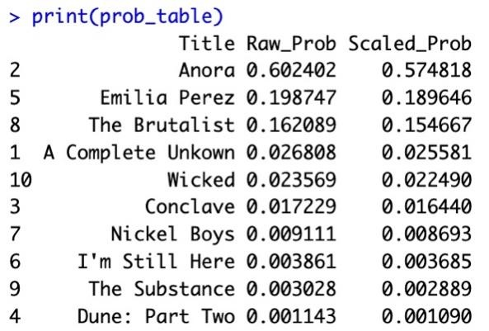
Figure 10

Figure 10 demonstrates the result of the table.
Anora has the highest predicted probability of winning, with a normalized chance of 57.5%. Emilia Perez and The Brutalist follow with 18.96% and 15.47%, respectively. In contrast, films like Dune: Part Two and The Substance show very low predicted chances under the model.

=== Q5 ===
Logistic regression is not the suitable approach to model this type of data because it assumes binary outcomes and treats each observation independently. While in the context of Best Picture nominees, only one film wins each year, and the outcomes are mutually exclusive within a given year. Therefore, modelling each film independently does not satisfy this assumption.
I researched online and find out that random forest classifier could be the alternative model that I can apply to predict the Oscar winners. Random forests can model non-linear relationships and output class probabilities. However it evaluates each data point independently, so the predicted probabilities across nominees in the same year do not automatically sum to 1. Therefore I normalized it manually after prediction. Figure 11 presents the raw and scaled probabilities predicted by the Random Forest model for 2024 Best Picture nominees. Anora again ranks highest with a scaled probability of 24.4%, followed by The Brutalist and Emilia Perez with 23.5% and 21.3%, respectively.
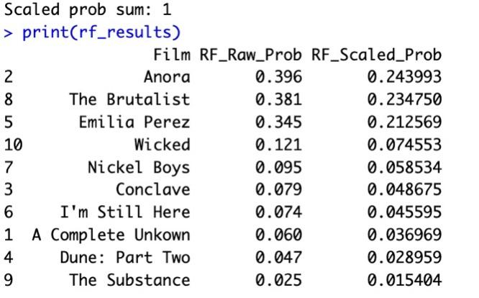
Figure 11
I generated this table by the following steps:
1. Installed the random forest package in R
2. Trained a Random Forest classifier using the cleaned dataset.
3. Predicted class probabilities for 2024 nominees.
4. Scaled the predicted probabilities so that they sum to 1.

Appendix
#Q1
cat("\n===Q1===\n")
oscars<-read.csv("~/Desktop/oscars.TXT.csv")
print(str(oscars))
cleaneddata<-subset(oscars, Year != 2024)
cleaneddata$Win_oscar_new_Ch<-ifelse(cleaneddata$Ch == 1,1,0)
cleaneddata<-subset(cleaneddata, select = -c(Ch, Year, Name, Pic))
# I cleanned data for 2024 because current year unknown, I cleanned date 'Name' because Names are strings, not number.
# cleaned Pic because all results for it is 1
# y is Ch and and Xs are the other variables including Nom,Dir,Aml,Afl...all other variables excluding Pic, name
print(table(cleaneddata$Win_oscar_new_Ch))
print(sum(is.na(cleaneddata)))
the_full_model<- glm(Win_oscar_new_Ch~.,
data = cleaneddata,
family = binomial)
#fitted full model
print(summary(the_full_model))
#found out significant coefficients. In those, for example Edi has p value of 0.03223 which is smaller than 0.05, this means that it is significant
edi_ci <- confint.default(the_full_model)["Edi", ]
print(edi_ci)
coef<-coef(the_full_model)["Edi"]
exp(coef)
#getting confidence interval, the significant coefficient and odds ratio
#In the full logistic regression model, p value is 0.03223 which is< 0.05 so Edi is significant. 95% confidence interval is (0.1023164 2.3115493), it doesn't include 0, positive and statistically significant.The variable Edi has a significant coefficient of 1.206933.Which means 1 unit increase in Edi then there is an increase of 1.2069 in the log-odds of winning an Oscar, this corresponds to an odds ratio of 3.34 (exp(1.2069)), suggesting that each 1 unit increase in Edi multiplies the odds of winning by about 3.345 times, the odds of winning increase by 234%.

#Q2
# I am using forward stepwise logistic regression as my model selection method.
# The selection metric is Akaike Information Criterion (AIC), I chose AIC because it has good fit but also avoids overfitting by penalizing too many variables.
# Selection process starts from building a null logistic regression model that includes only the intercept.
# Then variables are added one at a time.
# At each step, the variable that leads to the greatest AIC reduction is added.
# This continues until no further reduction in AIC can be done.
# (trace = 2 shows the selection process by steps)
cat("\n=== Final Model Variables ===\n")
the_stepwise_model<- step(glm(Win_oscar_new_Ch ~1, data = cleaneddata, family = binomial),
scope = formula(the_full_model),
direction = "forward",
trace = 2)
# Output the selected variables in the final model
cat("\nSelected Variables in Final Model:\n")
print(names(coef(the_stepwise_model)))

# Compare AIC between the full model and the stepwise-selected model
cat("\nAIC Comparison:\n")
cat("Full Model AIC:", round(AIC(the_full_model), 2), "\n")
cat("Stepwise Model AIC:", round(AIC(the_stepwise_model), 2), "\n")

# Show excluded variables
cat("\nExcluded Variables:\n")
excluded_vars <- setdiff(names(coef(the_full_model)), names(coef(the_stepwise_model)))
print(excluded_vars)

# Print the summary of the final selected model
cat("\nModel Summary:\n")
print(summary(the_stepwise_model))

# Visualize AIC change during selection
cat("\nAIC Change Plot:\n")
plot(the_stepwise_model)
#The full model had an AIC of 388.01, while the final model selected through
#stepwise selection had an AIC of 315.94, indicating a better fit.
#The final model includes the following variables: PGA, Dir, Edi, Dan, Gdr,
#SciFi, Days, NSFC, Ebert, and Nom. These variables were selected because
#they are either significantly reduced the AIC or were statistically meaningful.
#However, variables such as Aml, Afl, Art, PG13, Drama, and others were
#excluded, as they did not meaningfully improve the model based on AIC or had high p-values.

#Q3
install.packages("pROC")
library(pROC)

cat("\n=== Model Evaluation using ROC Analysis ===\n")

#Step 1: Generate predicted probabilities from the refined model
prob_scores <- predict(the_stepwise_model, type = "response")
#Step 2: Construct the ROC curve
roc_eval <- roc(response = cleaneddata$Win_oscar_new_Ch, predictor = prob_scores)
# Step 3: Visualize the ROC curve and annotate the AUC
plot(roc_eval, print.auc = TRUE, col = "pink", lwd = 2,
main = "ROC Curve - Logistic Regression Final Model")
# Step 4: Determine the optimal classification threshold using Youden's Index
optimal_cutoff <- coords(roc_eval, x = "best", ret = "threshold")[[1]]
# Step 5: Convert probabilities into predicted classes based on the threshold
class_predictions <- ifelse(prob_scores > optimal_cutoff, 1, 0)
# Step 6: Construct the confusion matrix
conf_results <- table(Observed = cleaneddata$Win_oscar_new_Ch,
Predicted = class_predictions)
print(conf_results)
# Step 7: Compute sensitivity (recall) and specificity
sensitivity_val <- conf_results[2, 2] / sum(conf_results[2, ])
specificity_val <- conf_results[1, 1] / sum(conf_results[1, ])
# Step 8: Print evaluation metrics
cat("\nOptimal Threshold (Youden Index):", round(optimal_cutoff, 3))
cat("\nSensitivity (True Positive Rate):", round(sensitivity_val, 3))
cat("\nSpecificity (True Negative Rate):", round(specificity_val, 3))
cat("\nArea Under the Curve (AUC):", round(auc(roc_eval), 3))
# to conclude, the plot shows that area Under the curve is 0.916, this shows strong
# performance in distinguishing Oscar winners from non-winners.The model has good classification ability
# The optimal threshold is 0.111 using Youden's Index
# At 0.111 threshold, model's sensitivity is 0.875 — meaning 87.5% of true winners were correctly predicted.

#Q4
cat("\n--- Q4: Predicting 2024 Best Picture Probabilities ---\n")
# Step 1: read data and extract 2024 entries using subset
raw_data <- read.csv("~/Desktop/oscars.TXT.csv")
nominees_2024 <- subset(raw_data, Year == 2024,
select = -c(Name, Year, Ch, Pic))
# Step 2, check if variable names match those used in model training
cat("Checking predictor variable alignment:\n")

print(str(data_2024))
cat("Checking predictor variable alignment:\n")
is_compatible <- identical(
names(nominees_2024),
names(cleaneddata)[names(cleaneddata) != "Win_oscar_new_Ch"]
)
cat("Match with training predictors:", is_compatible, "\n")

# step 3, it is compatible, predict raw probabilities using the final logistic model
prob_estimates <- predict(the_stepwise_model,
newdata = nominees_2024,
type = "response")
# step 4: Normalize the probabilities so they sum to 1
prob_normalized <- prob_estimates / sum(prob_estimates)

# Step 5: Construct and sort the results table
movie_titles <- subset(raw_data, Year == 2024)$Name
prob_table <- data.frame(
Title = movie_titles,
Raw_Prob = round(prob_estimates, 6),
Scaled_Prob = round(prob_normalized, 6)
)
prob_table <- prob_table[order(-prob_table$Scaled_Prob), ]

# Step 6: Print sum checks and final output
cat("\n=== Probability Verification ===\n")
cat("sum of raw probabilities:", sum(prob_estimates), "\n")
cat("sum of normalized probabilities:", sum(prob_normalized))
prob_table<- prob_table[order(-prob_table$Scaled_Prob),]
print(prob_table)

#Q5

#I researched online and find out that random forest could work.
# === Q5: Alternative Model – Random Forest ===
cat("\n--- Q5: Using Random Forest to Predict Probabilities ---\n")

# Load the randomForest library
install.packages("randomForest")
library(randomForest)

# Step 1: Train a classification Random Forest model
rf_fit <- randomForest(
as.factor(Win_oscar_new_Ch) ~ ., # convert response to factor to do classification
data = cleaneddata,
ntree = 1000,
importance = TRUE
)

# Step 2: Predict class probabilities on 2024 nominees
rf_pred_prob <- predict(rf_fit, newdata = nominees_2024, type = "prob")[, "1"]

# Step 3: Normalize probabilities within 2024 nominees
rf_prob_scaled <- rf_pred_prob / sum(rf_pred_prob)

# Step 4: Assemble results into a table
rf_results <- data.frame(
Film = subset(raw_data, Year == 2024)$Name,
RF_Raw_Prob = round(rf_pred_prob, 6),
RF_Scaled_Prob = round(rf_prob_scaled, 6)
)
rf_results <- rf_results[order(-rf_results$RF_Scaled_Prob), ]

# Step 5: Output result
cat("\n--- Random Forest Probability Summary ---\n")
cat("Raw prob sum:", round(sum(rf_pred_prob), 4), "\n")
cat("Scaled prob sum:", round(sum(rf_prob_scaled), 4), "\n")
print(rf_results)

Output
===Q1===
> oscars<-read.csv("~/Desktop/oscars.TXT.csv")
> print(str(oscars))
'data.frame': 614 obs. of 68 variables:
$ Year : int 2024 2024 2024 2024 2024 2024 2024 2024 2024 2024 ...
$ Name : chr "A Complete Unkown" "Anora" "Conclave" "Dune: Part Two" ...
$ Ch : int 0 0 0 0 0 0 0 0 0 0 ...
$ Nom : int 8 6 8 5 13 3 2 10 5 10 ...
$ Pic : int 1 1 1 1 1 1 1 1 1 1 ...
$ Dir : int 1 1 0 0 1 0 0 1 1 0 ...
$ Aml : int 1 0 1 0 0 0 0 1 0 0 ...
$ Afl : int 0 1 0 0 1 1 0 0 1 1 ...
$ Ams : int 1 1 0 0 0 0 0 1 0 0 ...
$ Afs : int 1 0 1 0 1 0 0 1 0 1 ...
$ Scr : int 1 1 1 0 1 0 1 1 1 0 ...
$ Cin : int 0 0 0 1 1 0 0 1 0 0 ...
$ Art : int 0 0 1 1 0 0 0 0 0 1 ...
$ Cos : int 1 0 1 0 0 0 0 0 0 1 ...
$ Sco : int 0 0 1 0 1 0 0 1 0 1 ...
$ Son : int 0 0 0 0 1 0 0 0 0 0 ...
$ Edi : int 0 1 1 0 1 0 0 1 0 1 ...
$ Sou : int 1 0 0 1 1 0 0 0 0 1 ...
$ For : int 0 0 0 0 1 1 0 0 0 0 ...
$ Anf : int 0 0 0 0 0 0 0 0 0 0 ...
$ Eff : int 0 0 0 1 1 0 0 0 0 1 ...
$ Mak : int 0 0 0 0 1 0 0 0 1 1 ...
$ Dan : int 0 0 0 0 0 0 0 0 0 0 ...
$ AD : int 0 0 0 0 0 0 0 0 0 0 ...
$ Gdr : int 0 0 0 0 0 0 0 1 0 0 ...
$ Gmc : int 0 0 0 0 1 0 0 0 0 0 ...
$ Gd : int 0 0 0 0 0 0 0 1 0 0 ...
$ Gm1 : int 0 0 0 0 0 0 0 1 0 0 ...
$ Gm2 : int 0 0 0 0 0 0 0 0 0 0 ...
$ Gf1 : int 0 0 0 0 0 1 0 0 0 0 ...
$ Gf2 : int 0 0 0 0 0 0 0 0 1 0 ...
$ PGA : int 0 1 0 0 0 0 0 0 0 0 ...
$ DGA : int 0 1 0 0 0 0 1 0 0 0 ...
$ Action : int 0 0 0 1 0 0 0 0 0 0 ...
$ Adventure: int 0 0 0 1 0 0 0 0 0 0 ...
$ Animation: int 0 0 0 0 0 0 0 0 0 0 ...
$ Biography: int 1 0 0 0 0 1 0 0 0 0 ...
$ Comedy : int 0 1 0 0 1 0 0 0 1 0 ...
$ Crime : int 0 0 0 0 1 0 0 0 0 0 ...
$ Docu : int 1 0 0 0 0 1 0 0 0 0 ...
$ Drama : int 1 1 1 1 1 1 1 1 1 0 ...
$ Family : int 0 0 0 0 0 0 0 0 0 0 ...
$ Fantasy : int 0 0 0 1 0 0 0 0 0 1 ...
$ Film.noir: int 0 0 0 0 0 0 0 0 0 0 ...
$ History : int 0 0 0 0 0 1 0 0 0 0 ...
$ Horror : int 0 0 0 0 0 0 0 0 1 0 ...
$ Music : int 1 0 0 0 0 0 0 0 0 0 ...
$ Musical : int 0 0 0 0 1 0 0 0 0 1 ...
$ Mystery : int 0 0 1 0 0 0 0 0 0 0 ...
$ Romance : int 0 1 0 0 0 0 0 0 0 1 ...
$ SciFi : int 0 0 0 1 0 0 0 0 1 0 ...
$ Sport : int 0 0 0 0 0 0 0 0 0 0 ...
$ Thriller : int 0 0 1 0 0 0 0 0 0 0 ...
$ War : int 0 0 0 0 0 0 0 0 0 0 ...
$ Western : int 0 0 0 0 0 0 0 0 0 0 ...
$ Length : int 141 139 120 166 130 137 140 214 141 160 ...
$ Days : int 68 121 128 367 288 144 41 37 163 100 ...
$ G : int 0 0 0 0 0 0 0 0 0 0 ...
$ PG : int 0 0 1 0 0 0 0 0 0 1 ...
$ PG13 : int 0 0 0 1 0 1 1 0 0 0 ...
$ R : int 1 1 0 0 1 0 0 1 1 0 ...
$ U : int 0 0 0 0 0 0 0 0 0 0 ...
$ Ebert : num 3.5 4 4 3.5 3 4 4 4 3.5 3 ...
$ NYFCC : int 0 0 0 0 0 0 0 1 0 0 ...
$ LAFCA : int 0 1 0 0 0 0 0 0 0 0 ...
$ NSFC : int 0 0 0 0 0 0 1 0 0 0 ...
$ NBR : int 0 0 0 0 0 0 0 0 0 1 ...
$ WR : num 7.6 7.7 7.4 8.5 5.5 8.8 7.3 7.9 7.3 7.6 ...
NULL
> cleaneddata<-subset(oscars, Year != 2024)
> cleaneddata$Win_oscar_new_Ch<-ifelse(cleaneddata$Ch == 1,1,0)
> cleaneddata<-subset(cleaneddata, select = -c(Ch, Year, Name, Pic))
> # I cleanned data for 2024 because current year unknown, I cleanned date 'Name' because Names are strings, not number.
> # cleaned Pic because all results for it is 1
> # y is Ch and and Xs are the other variables including Nom,Dir,Aml,Afl...all other variables excluding Pic, name
> print(table(cleaneddata$Win_oscar_new_Ch))

0 1
508 96
> print(sum(is.na(cleaneddata)))
[1] 0
> the_full_model<- glm(Win_oscar_new_Ch~.,
+ data = cleaneddata,
+ family = binomial)
> #fitted full model
> print(summary(the_full_model))

Call:
glm(formula = Win_oscar_new_Ch ~ ., family = binomial, data = cleaneddata)

Coefficients:
Estimate Std. Error z value Pr(>|z|)
(Intercept) -9.459e+00 3.063e+00 -3.088 0.00202 **
Nom -1.143e-02 3.910e-01 -0.029 0.97668
Dir 1.780e+00 6.959e-01 2.557 0.01055 *
Aml -1.211e-02 4.934e-01 -0.025 0.98041
Afl 2.905e-01 5.629e-01 0.516 0.60578
Ams 6.048e-01 4.765e-01 1.269 0.20438
Afs 1.481e-01 4.990e-01 0.297 0.76660
Scr 3.845e-01 6.442e-01 0.597 0.55063
Cin -1.487e-01 5.846e-01 -0.254 0.79921
Art 2.350e-01 5.889e-01 0.399 0.68985
Cos -5.047e-01 6.502e-01 -0.776 0.43754
Sco 2.931e-01 5.493e-01 0.534 0.59357
Son -1.610e-01 8.498e-01 -0.190 0.84970
Edi 1.207e+00 5.636e-01 2.142 0.03223 *
Sou -5.270e-01 6.362e-01 -0.828 0.40744
For 4.318e-01 1.465e+00 0.295 0.76824
Anf 1.065e+00 4.817e+03 0.000 0.99982
Eff 2.175e-01 6.460e-01 0.337 0.73630
Mak 1.457e+00 9.438e-01 1.544 0.12257
Dan 2.769e+00 1.628e+00 1.701 0.08895 .
AD 1.683e+00 1.314e+00 1.281 0.20003
Gdr 1.305e+00 4.610e-01 2.830 0.00465 **
Gmc -1.290e-01 7.790e-01 -0.166 0.86850
Gd -2.950e+00 1.770e+00 -1.667 0.09556 .
Gm1 1.467e+00 1.269e+00 1.157 0.24740
Gm2 -1.193e+00 3.497e+00 -0.341 0.73293
Gf1 -1.558e+00 1.807e+00 -0.862 0.38856
Gf2 -1.435e+01 1.772e+03 -0.008 0.99354
PGA 3.571e+00 4.994e-01 7.150 8.69e-13 ***
DGA 1.905e+00 1.331e+00 1.431 0.15240
Action -6.718e-01 7.969e-01 -0.843 0.39925
Adventure -2.477e-01 7.548e-01 -0.328 0.74279
Animation -1.172e+01 3.956e+03 -0.003 0.99764
Biography -5.795e-01 6.509e-01 -0.890 0.37334
Comedy -1.364e-01 5.373e-01 -0.254 0.79953
Crime 1.021e+00 6.313e-01 1.617 0.10594
Docu -1.333e+01 3.956e+03 -0.003 0.99731
Drama -9.871e-01 6.238e-01 -1.582 0.11359
Family 1.222e+00 8.718e-01 1.402 0.16102
Fantasy -1.039e+00 1.169e+00 -0.888 0.37443
Film.noir -6.244e-01 1.425e+00 -0.438 0.66130
History 3.740e-01 7.037e-01 0.531 0.59508
Horror -8.303e-01 2.053e+00 -0.404 0.68593
Music 7.516e-01 9.649e-01 0.779 0.43604
Musical 8.186e-01 8.582e-01 0.954 0.34012
Mystery 6.285e-01 7.954e-01 0.790 0.42944
Romance 4.362e-01 4.183e-01 1.043 0.29704
SciFi -1.084e+00 1.637e+00 -0.662 0.50792
Sport 5.060e-01 1.178e+00 0.430 0.66745
Thriller -8.074e-01 7.014e-01 -1.151 0.24973
War 9.575e-01 6.376e-01 1.502 0.13317
Western -3.627e-02 9.434e-01 -0.038 0.96933
Length 1.789e-03 8.491e-03 0.211 0.83311
Days 2.381e-03 1.621e-03 1.469 0.14174
G -1.985e+00 2.029e+00 -0.978 0.32803
PG -1.135e+00 6.883e-01 -1.649 0.09922 .
PG13 -1.424e+00 8.666e-01 -1.643 0.10038
R -1.438e+00 7.088e-01 -2.030 0.04241 *
U -1.384e+01 1.989e+03 -0.007 0.99445
Ebert 1.325e-01 1.683e-01 0.787 0.43115
NYFCC 1.660e-01 4.684e-01 0.354 0.72304
LAFCA -8.886e-01 7.154e-01 -1.242 0.21423
NSFC 1.880e+00 7.502e-01 2.506 0.01221 *
NBR -1.391e-01 4.917e-01 -0.283 0.77719
WR 5.265e-01 3.997e-01 1.317 0.18771
---
Signif. codes: 0 ‘***’ 0.001 ‘**’ 0.01 ‘*’ 0.05 ‘.’ 0.1 ‘ ’ 1

(Dispersion parameter for binomial family taken to be 1)

Null deviance: 528.99 on 603 degrees of freedom
Residual deviance: 258.01 on 539 degrees of freedom
AIC: 388.01

Number of Fisher Scoring iterations: 16

> #found out significant coefficients. In those, for example Edi has p value of 0.03223 which is smaller than 0.05, this means that it is significant
> edi_ci <- confint.default(the_full_model)["Edi", ]
> print(edi_ci)
2.5 % 97.5 %
0.1023164 2.3115493
> coef<-coef(the_full_model)["Edi"]
> exp(coef)
Edi
3.343215

#Q2
> # I am using forward stepwise logistic regression as my model selection method.
> # The selection metric is Akaike Information Criterion (AIC), I chose AIC because it has good fit but also avoids overfitting by penalizing too many variables.
> # Selection process starts from building a null logistic regression model that includes only the intercept.
> # Then variables are added one at a time.
> # At each step, the variable that leads to the greatest AIC reduction is added.
> # This continues until no further reduction in AIC can be done.
> # (trace = 2 shows the selection process by steps)
> cat("\n=== Final Model Variables ===\n")

=== Final Model Variables ===
> the_stepwise_model<- step(glm(Win_oscar_new_Ch ~1, data = cleaneddata, family = binomial),
+ scope = formula(the_full_model),
+ direction = "forward",
+ trace = 2)
Start: AIC=530.99
Win_oscar_new_Ch ~ 1

Df Deviance AIC
+ PGA 1 370.91 374.91
+ Nom 1 445.86 449.86
+ Dir 1 465.34 469.34
+ Gdr 1 467.14 471.14
+ Edi 1 480.51 484.51
+ WR 1 494.66 498.66
+ NYFCC 1 496.20 500.20
+ Ams 1 499.47 503.47
+ Length 1 509.60 513.60
+ Aml 1 510.37 514.37
+ Scr 1 511.42 515.42
+ Cos 1 513.05 517.05
+ Cin 1 513.57 517.57
+ Sou 1 516.92 520.92
+ Art 1 518.49 522.49
+ DGA 1 518.80 522.80
+ Sco 1 520.09 524.09
+ NBR 1 520.11 524.11
+ Mak 1 520.23 524.23
+ Afs 1 523.57 527.57
+ Dan 1 523.93 527.93
+ NSFC 1 523.98 527.98
+ LAFCA 1 525.04 529.04
+ War 1 525.55 529.55
+ Gmc 1 526.11 530.11
+ Eff 1 526.25 530.25
<none> 528.99 530.99
+ Crime 1 527.12 531.12
+ Musical 1 527.29 531.29
+ Gf2 1 527.60 531.60
+ Fantasy 1 527.61 531.61
+ SciFi 1 527.79 531.79
+ Afl 1 527.93 531.93
+ Animation 1 527.95 531.95
+ U 1 527.95 531.95
+ Romance 1 527.96 531.96
+ R 1 527.97 531.97
+ G 1 528.00 532.00
+ Gm1 1 528.06 532.06
+ Comedy 1 528.28 532.28
+ Anf 1 528.30 532.30
+ PG13 1 528.33 532.33
+ AD 1 528.38 532.38
+ Ebert 1 528.42 532.42
+ Gm2 1 528.44 532.44
+ Gd 1 528.60 532.60
+ Family 1 528.62 532.62
+ Docu 1 528.65 532.65
+ Drama 1 528.65 532.65
+ Action 1 528.69 532.69
+ Film.noir 1 528.70 532.70
+ For 1 528.70 532.70
+ Thriller 1 528.76 532.76
+ Mystery 1 528.76 532.76
+ Son 1 528.78 532.78
+ Western 1 528.90 532.90
+ Gf1 1 528.92 532.92
+ History 1 528.95 532.95
+ Music 1 528.98 532.98
+ Biography 1 528.98 532.98
+ Sport 1 528.99 532.99
+ Days 1 528.99 532.99
+ Adventure 1 528.99 532.99
+ Horror 1 528.99 532.99
+ PG 1 528.99 532.99

Step: AIC=374.91
Win_oscar_new_Ch ~ PGA

Df Deviance AIC
+ Dir 1 338.74 344.74
+ Nom 1 348.15 354.15
+ Edi 1 348.27 354.27
+ Gdr 1 355.15 361.15
+ NYFCC 1 362.55 368.55
+ NSFC 1 363.00 369.00
+ Scr 1 363.57 369.57
+ WR 1 364.27 370.27
+ Ams 1 364.29 370.29
+ Dan 1 365.18 371.18
+ Length 1 365.30 371.30
+ Aml 1 365.31 371.31
+ SciFi 1 367.05 373.05
+ PG13 1 367.27 373.27
+ Cin 1 367.96 373.96
+ Sco 1 368.22 374.22
+ DGA 1 368.23 374.23
+ Crime 1 368.68 374.68
+ Family 1 368.72 374.72
+ Romance 1 368.88 374.88
+ Gm1 1 368.89 374.89
+ Musical 1 368.89 374.89
<none> 370.91 374.91
+ Art 1 368.93 374.93
+ Cos 1 368.94 374.94
+ War 1 369.09 375.09
+ Ebert 1 369.47 375.47
+ Days 1 369.59 375.59
+ Afs 1 369.87 375.87
+ Sou 1 369.95 375.95
+ Fantasy 1 369.95 375.95
+ PG 1 370.00 376.00
+ LAFCA 1 370.19 376.19
+ Mak 1 370.20 376.20
+ Gf2 1 370.28 376.28
+ NBR 1 370.30 376.30
+ History 1 370.32 376.32
+ Animation 1 370.44 376.44
+ U 1 370.44 376.44
+ Mystery 1 370.50 376.50
+ Action 1 370.52 376.52
+ Eff 1 370.59 376.59
+ Anf 1 370.59 376.59
+ Thriller 1 370.60 376.60
+ Son 1 370.62 376.62
+ Sport 1 370.73 376.73
+ Docu 1 370.75 376.75
+ Music 1 370.76 376.76
+ Gf1 1 370.80 376.80
+ Drama 1 370.81 376.81
+ Film.noir 1 370.83 376.83
+ For 1 370.83 376.83
+ Afl 1 370.85 376.85
+ Gmc 1 370.87 376.87
+ Gm2 1 370.87 376.87
+ Horror 1 370.88 376.88
+ Comedy 1 370.89 376.89
+ Biography 1 370.89 376.89
+ AD 1 370.90 376.90
+ R 1 370.90 376.90
+ G 1 370.91 376.91
+ Adventure 1 370.91 376.91
+ Gd 1 370.91 376.91
+ Western 1 370.91 376.91

Step: AIC=344.74
Win_oscar_new_Ch ~ PGA + Dir

Df Deviance AIC
+ Edi 1 324.47 332.47
+ Gdr 1 329.99 337.99
+ Nom 1 330.58 338.58
+ Dan 1 332.03 340.03
+ SciFi 1 334.37 342.37
+ Musical 1 334.67 342.67
+ NSFC 1 334.86 342.86
+ Ams 1 334.89 342.89
+ Length 1 335.38 343.38
+ Gm1 1 335.76 343.76
+ NYFCC 1 335.90 343.90
+ WR 1 336.13 344.13
+ Scr 1 336.49 344.49
+ Romance 1 336.50 344.50
+ Days 1 336.56 344.56
+ Ebert 1 336.59 344.59
+ Sco 1 336.62 344.62
<none> 338.74 344.74
+ Family 1 337.07 345.07
+ War 1 337.22 345.22
+ Art 1 337.24 345.24
+ Aml 1 337.29 345.29
+ Mak 1 337.35 345.35
+ PG13 1 337.38 345.38
+ Fantasy 1 337.49 345.49
+ DGA 1 337.54 345.54
+ PG 1 337.74 345.74
+ R 1 337.90 345.90
+ Gf2 1 337.93 345.93
+ Cos 1 337.98 345.98
+ History 1 338.04 346.04
+ Crime 1 338.12 346.12
+ Cin 1 338.16 346.16
+ Sou 1 338.18 346.18
+ Action 1 338.19 346.19
+ U 1 338.19 346.19
+ NBR 1 338.22 346.22
+ Thriller 1 338.32 346.32
+ Drama 1 338.41 346.41
+ Mystery 1 338.44 346.44
+ Music 1 338.50 346.50
+ AD 1 338.50 346.50
+ Eff 1 338.55 346.55
+ Sport 1 338.57 346.57
+ Afs 1 338.57 346.57
+ Gf1 1 338.57 346.57
+ Horror 1 338.60 346.60
+ Film.noir 1 338.60 346.60
+ Gd 1 338.60 346.60
+ Gmc 1 338.60 346.60
+ Biography 1 338.61 346.61
+ Animation 1 338.65 346.65
+ G 1 338.66 346.66
+ Anf 1 338.68 346.68
+ Comedy 1 338.71 346.71
+ Docu 1 338.71 346.71
+ Western 1 338.73 346.73
+ For 1 338.73 346.73
+ Adventure 1 338.74 346.74
+ LAFCA 1 338.74 346.74
+ Afl 1 338.74 346.74
+ Gm2 1 338.74 346.74
+ Son 1 338.74 346.74

Step: AIC=332.47
Win_oscar_new_Ch ~ PGA + Dir + Edi

Df Deviance AIC
+ Dan 1 318.48 328.48
+ SciFi 1 318.50 328.50
+ Gdr 1 319.02 329.02
+ Ebert 1 320.14 330.14
+ Days 1 321.06 331.06
+ Romance 1 321.07 331.07
+ Musical 1 321.12 331.12
+ NSFC 1 321.54 331.54
+ Scr 1 321.61 331.61
+ Ams 1 321.84 331.84
+ NYFCC 1 321.86 331.86
+ PG13 1 322.31 332.31
<none> 324.47 332.47
+ Thriller 1 322.60 332.60
+ Fantasy 1 322.61 332.61
+ Gm1 1 322.74 332.74
+ Nom 1 322.84 332.84
+ R 1 322.92 332.92
+ Action 1 322.99 332.99
+ Drama 1 323.34 333.34
+ Family 1 323.37 333.37
+ Aml 1 323.41 333.41
+ DGA 1 323.46 333.46
+ PG 1 323.56 333.56
+ Gf2 1 323.56 333.56
+ Length 1 323.63 333.63
+ War 1 323.72 333.72
+ WR 1 323.78 333.78
+ U 1 323.91 333.91
+ Gf1 1 323.95 333.95
+ Comedy 1 323.98 333.98
+ History 1 324.00 334.00
+ Mak 1 324.00 334.00
+ AD 1 324.08 334.08
+ NBR 1 324.11 334.11
+ Horror 1 324.14 334.14
+ Afs 1 324.19 334.19
+ Art 1 324.20 334.20
+ Crime 1 324.20 334.20
+ Sport 1 324.22 334.22
+ Sco 1 324.22 334.22
+ Film.noir 1 324.31 334.31
+ Gd 1 324.31 334.31
+ Sou 1 324.32 334.32
+ G 1 324.34 334.34
+ LAFCA 1 324.37 334.37
+ Cos 1 324.37 334.37
+ Adventure 1 324.38 334.38
+ Gm2 1 324.39 334.39
+ Animation 1 324.41 334.41
+ Mystery 1 324.42 334.42
+ Son 1 324.42 334.42
+ Gmc 1 324.43 334.43
+ Music 1 324.43 334.43
+ Anf 1 324.43 334.43
+ Western 1 324.44 334.44
+ Eff 1 324.45 334.45
+ Biography 1 324.45 334.45
+ Docu 1 324.45 334.45
+ For 1 324.45 334.45
+ Cin 1 324.46 334.46
+ Afl 1 324.46 334.46

Step: AIC=328.48
Win_oscar_new_Ch ~ PGA + Dir + Edi + Dan

Df Deviance AIC
+ Gdr 1 312.38 324.38
+ SciFi 1 312.66 324.66
+ NSFC 1 315.18 327.18
+ Ebert 1 315.21 327.21
+ Days 1 315.23 327.23
+ Romance 1 315.58 327.58
+ NYFCC 1 315.62 327.62
+ Scr 1 315.77 327.77
+ Ams 1 315.79 327.79
<none> 318.48 328.48
+ Gm1 1 316.60 328.60
+ PG13 1 316.60 328.60
+ Fantasy 1 316.78 328.78
+ Thriller 1 316.90 328.90
+ Nom 1 317.14 329.14
+ Action 1 317.18 329.18
+ WR 1 317.26 329.26
+ Aml 1 317.26 329.26
+ R 1 317.35 329.35
+ DGA 1 317.39 329.39
+ Drama 1 317.48 329.48
+ War 1 317.54 329.54
+ Musical 1 317.58 329.58
+ Gf2 1 317.62 329.62
+ PG 1 317.74 329.74
+ History 1 317.88 329.88
+ Mak 1 317.89 329.89
+ Family 1 317.94 329.94
+ U 1 317.95 329.95
+ NBR 1 317.96 329.96
+ Length 1 318.00 330.00
+ Gf1 1 318.01 330.01
+ AD 1 318.04 330.04
+ Afs 1 318.04 330.04
+ Horror 1 318.19 330.19
+ Sport 1 318.19 330.19
+ Comedy 1 318.20 330.20
+ Sco 1 318.22 330.22
+ G 1 318.25 330.25
+ Film.noir 1 318.29 330.29
+ Sou 1 318.30 330.30
+ Gd 1 318.36 330.36
+ Crime 1 318.37 330.37
+ Mystery 1 318.39 330.39
+ Music 1 318.42 330.42
+ Gm2 1 318.42 330.42
+ Art 1 318.42 330.42
+ Animation 1 318.43 330.43
+ Gmc 1 318.44 330.44
+ LAFCA 1 318.44 330.44
+ Son 1 318.44 330.44
+ Cos 1 318.44 330.44
+ Adventure 1 318.45 330.45
+ Anf 1 318.45 330.45
+ Docu 1 318.47 330.47
+ Cin 1 318.47 330.47
+ Western 1 318.47 330.47
+ For 1 318.48 330.48
+ Biography 1 318.48 330.48
+ Eff 1 318.48 330.48
+ Afl 1 318.48 330.48

Step: AIC=324.38
Win_oscar_new_Ch ~ PGA + Dir + Edi + Dan + Gdr

Df Deviance AIC
+ SciFi 1 307.48 321.48
+ Days 1 308.17 322.17
+ NSFC 1 308.65 322.65
+ Ebert 1 308.85 322.85
+ Romance 1 309.08 323.08
+ NYFCC 1 310.28 324.28
+ Ams 1 310.29 324.29
<none> 312.38 324.38
+ Scr 1 310.44 324.44
+ PG13 1 310.48 324.48
+ Action 1 310.51 324.52
+ Thriller 1 310.81 324.81
+ Fantasy 1 310.90 324.91
+ WR 1 310.92 324.92
+ Musical 1 310.95 324.95
+ Gm1 1 310.98 324.98
+ R 1 311.09 325.09
+ Drama 1 311.31 325.31
+ Comedy 1 311.39 325.39
+ War 1 311.46 325.46
+ Aml 1 311.48 325.48
+ Gd 1 311.56 325.56
+ U 1 311.56 325.56
+ Nom 1 311.57 325.57
+ PG 1 311.65 325.65
+ Gf2 1 311.66 325.66
+ Gmc 1 311.74 325.74
+ DGA 1 311.78 325.78
+ AD 1 311.82 325.82
+ Afs 1 311.85 325.85
+ Family 1 311.86 325.86
+ History 1 311.93 325.93
+ Horror 1 311.97 325.97
+ Mak 1 311.97 325.97
+ Gf1 1 311.97 325.97
+ Sport 1 312.02 326.02
+ Sou 1 312.03 326.03
+ NBR 1 312.03 326.03
+ LAFCA 1 312.12 326.12
+ Length 1 312.20 326.20
+ Music 1 312.22 326.22
+ Art 1 312.22 326.22
+ Crime 1 312.23 326.23
+ G 1 312.24 326.24
+ Adventure 1 312.26 326.26
+ Cos 1 312.32 326.32
+ Mystery 1 312.32 326.33
+ Animation 1 312.33 326.33
+ Western 1 312.33 326.33
+ Anf 1 312.35 326.35
+ Film.noir 1 312.35 326.35
+ Sco 1 312.35 326.35
+ Eff 1 312.36 326.36
+ Docu 1 312.37 326.37
+ Biography 1 312.37 326.37
+ Cin 1 312.38 326.38
+ Son 1 312.38 326.38
+ Gm2 1 312.38 326.38
+ For 1 312.38 326.38
+ Afl 1 312.38 326.38

Step: AIC=321.48
Win_oscar_new_Ch ~ PGA + Dir + Edi + Dan + Gdr + SciFi

Df Deviance AIC
+ Days 1 302.95 318.95
+ NSFC 1 304.21 320.21
+ Ebert 1 304.64 320.64
+ Romance 1 304.75 320.75
+ Drama 1 304.91 320.91
+ Gm1 1 305.00 321.00
<none> 307.48 321.48
+ WR 1 305.71 321.71
+ Ams 1 305.87 321.87
+ R 1 305.95 321.95
+ NYFCC 1 306.09 322.09
+ Scr 1 306.14 322.14
+ Musical 1 306.31 322.31
+ PG13 1 306.37 322.37
+ DGA 1 306.43 322.43
+ Comedy 1 306.47 322.47
+ Nom 1 306.53 322.53
+ Action 1 306.54 322.54
+ Thriller 1 306.55 322.55
+ Family 1 306.66 322.66
+ PG 1 306.68 322.68
+ Gd 1 306.83 322.83
+ War 1 306.83 322.83
+ AD 1 306.87 322.87
+ Horror 1 306.98 322.98
+ Gf2 1 307.00 323.00
+ Gmc 1 307.04 323.04
+ Mak 1 307.06 323.05
+ History 1 307.13 323.13
+ Sport 1 307.15 323.15
+ Afs 1 307.16 323.16
+ Fantasy 1 307.17 323.17
+ Aml 1 307.18 323.18
+ Mystery 1 307.23 323.23
+ Eff 1 307.23 323.23
+ Art 1 307.24 323.23
+ Sou 1 307.27 323.27
+ U 1 307.28 323.28
+ NBR 1 307.31 323.31
+ G 1 307.31 323.31
+ Sco 1 307.37 323.37
+ Music 1 307.38 323.38
+ Western 1 307.39 323.40
+ Afl 1 307.40 323.40
+ Biography 1 307.41 323.41
+ Length 1 307.42 323.42
+ Crime 1 307.42 323.42
+ Animation 1 307.43 323.43
+ Cos 1 307.43 323.43
+ Adventure 1 307.44 323.44
+ Anf 1 307.44 323.44
+ Film.noir 1 307.45 323.45
+ Gm2 1 307.46 323.46
+ Docu 1 307.46 323.46
+ Gf1 1 307.47 323.47
+ For 1 307.47 323.47
+ Son 1 307.47 323.47
+ LAFCA 1 307.48 323.47
+ Cin 1 307.48 323.48

Step: AIC=318.95
Win_oscar_new_Ch ~ PGA + Dir + Edi + Dan + Gdr + SciFi + Days

Df Deviance AIC
+ NSFC 1 299.83 317.83
+ Romance 1 300.56 318.56
+ WR 1 300.77 318.77
+ Drama 1 300.84 318.84
+ Nom 1 300.92 318.92
+ Ams 1 300.95 318.95
<none> 302.95 318.95
+ Gm1 1 301.07 319.07
+ Ebert 1 301.33 319.33
+ R 1 301.62 319.62
+ Scr 1 301.75 319.75
+ Comedy 1 301.93 319.93
+ Action 1 301.97 319.97
+ NYFCC 1 302.01 320.01
+ DGA 1 302.02 320.02
+ Musical 1 302.07 320.07
+ Thriller 1 302.11 320.11
+ Gd 1 302.17 320.17
+ Family 1 302.19 320.19
+ Horror 1 302.23 320.23
+ Afs 1 302.25 320.25
+ PG 1 302.30 320.30
+ Mak 1 302.36 320.36
+ History 1 302.46 320.46
+ War 1 302.47 320.47
+ PG13 1 302.47 320.47
+ Sport 1 302.51 320.51
+ Aml 1 302.58 320.58
+ Gmc 1 302.60 320.60
+ Gf2 1 302.60 320.60
+ AD 1 302.61 320.61
+ Eff 1 302.66 320.66
+ Western 1 302.68 320.68
+ Sco 1 302.70 320.70
+ Art 1 302.72 320.72
+ U 1 302.73 320.73
+ Length 1 302.75 320.75
+ Mystery 1 302.76 320.76
+ Fantasy 1 302.77 320.77
+ Music 1 302.79 320.79
+ Cos 1 302.82 320.83
+ G 1 302.84 320.84
+ Afl 1 302.86 320.86
+ Gf1 1 302.87 320.86
+ Sou 1 302.87 320.87
+ Crime 1 302.88 320.88
+ Biography 1 302.88 320.88
+ Docu 1 302.88 320.88
+ Animation 1 302.90 320.90
+ Film.noir 1 302.90 320.90
+ Anf 1 302.91 320.91
+ NBR 1 302.91 320.91
+ Son 1 302.92 320.92
+ Gm2 1 302.94 320.94
+ LAFCA 1 302.94 320.94
+ Adventure 1 302.94 320.94
+ Cin 1 302.94 320.94
+ For 1 302.95 320.95

Step: AIC=317.83
Win_oscar_new_Ch ~ PGA + Dir + Edi + Dan + Gdr + SciFi + Days +
NSFC

Df Deviance AIC
+ Ebert 1 296.39 316.39
+ Romance 1 296.49 316.49
+ Nom 1 297.00 317.00
+ R 1 297.36 317.36
+ Ams 1 297.51 317.51
+ Drama 1 297.52 317.52
<none> 299.83 317.83
+ Gd 1 297.93 317.93
+ LAFCA 1 298.48 318.48
+ WR 1 298.51 318.51
+ Musical 1 298.62 318.62
+ Gm1 1 298.63 318.63
+ Scr 1 298.71 318.71
+ Thriller 1 298.85 318.85
+ Horror 1 298.87 318.87
+ Family 1 298.94 318.94
+ Comedy 1 298.95 318.95
+ Action 1 299.02 319.02
+ PG 1 299.07 319.07
+ Sco 1 299.21 319.21
+ Aml 1 299.21 319.21
+ PG13 1 299.24 319.24
+ Gf2 1 299.27 319.28
+ Afs 1 299.28 319.28
+ War 1 299.29 319.29
+ DGA 1 299.31 319.31
+ Mak 1 299.31 319.31
+ AD 1 299.39 319.39
+ Western 1 299.41 319.41
+ Art 1 299.49 319.49
+ Gf1 1 299.50 319.50
+ NYFCC 1 299.51 319.51
+ Gmc 1 299.53 319.53
+ Sport 1 299.55 319.55
+ Eff 1 299.56 319.56
+ G 1 299.56 319.56
+ Fantasy 1 299.56 319.56
+ Cos 1 299.59 319.59
+ For 1 299.60 319.60
+ Length 1 299.61 319.61
+ U 1 299.62 319.62
+ History 1 299.66 319.66
+ Biography 1 299.70 319.70
+ Afl 1 299.70 319.70
+ Film.noir 1 299.73 319.73
+ Music 1 299.74 319.74
+ Mystery 1 299.75 319.75
+ Docu 1 299.76 319.76
+ Crime 1 299.77 319.77
+ Animation 1 299.77 319.77
+ Son 1 299.77 319.77
+ Adventure 1 299.78 319.78
+ Sou 1 299.78 319.78
+ Anf 1 299.79 319.79
+ Cin 1 299.81 319.81
+ Gm2 1 299.82 319.82
+ NBR 1 299.82 319.82

Step: AIC=316.39
Win_oscar_new_Ch ~ PGA + Dir + Edi + Dan + Gdr + SciFi + Days +
NSFC + Ebert

Df Deviance AIC
+ Nom 1 293.94 315.94
+ Romance 1 294.03 316.03
+ Ams 1 294.17 316.17
+ WR 1 294.19 316.19
<none> 296.39 316.39
+ Gm1 1 294.82 316.82
+ Drama 1 294.82 316.82
+ Gd 1 295.03 317.03
+ Mak 1 295.10 317.10
+ Scr 1 295.24 317.24
+ DGA 1 295.26 317.26
+ Musical 1 295.42 317.42
+ Comedy 1 295.49 317.49
+ PG 1 295.68 317.68
+ Thriller 1 295.68 317.68
+ Action 1 295.71 317.71
+ LAFCA 1 295.72 317.72
+ Horror 1 295.73 317.73
+ R 1 295.75 317.75
+ Gf2 1 295.85 317.85
+ Eff 1 295.89 317.89
+ Gmc 1 295.91 317.91
+ Family 1 295.93 317.93
+ Western 1 295.97 317.97
+ War 1 295.97 317.97
+ Afs 1 295.98 317.98
+ Sco 1 295.98 317.98
+ Cos 1 296.03 318.03
+ Length 1 296.06 318.06
+ Fantasy 1 296.08 318.08
+ G 1 296.10 318.10
+ AD 1 296.14 318.14
+ For 1 296.14 318.14
+ Aml 1 296.15 318.15
+ Crime 1 296.15 318.16
+ NYFCC 1 296.21 318.21
+ Gf1 1 296.22 318.22
+ Sport 1 296.23 318.23
+ Music 1 296.24 318.24
+ U 1 296.25 318.25
+ Son 1 296.26 318.26
+ Art 1 296.26 318.26
+ Biography 1 296.27 318.27
+ PG13 1 296.30 318.30
+ History 1 296.30 318.30
+ Sou 1 296.30 318.30
+ Docu 1 296.33 318.33
+ Mystery 1 296.35 318.35
+ Animation 1 296.36 318.36
+ Afl 1 296.36 318.36
+ NBR 1 296.36 318.36
+ Anf 1 296.37 318.36
+ Adventure 1 296.37 318.37
+ Cin 1 296.38 318.38
+ Gm2 1 296.39 318.39
+ Film.noir 1 296.39 318.39

Step: AIC=315.94
Win_oscar_new_Ch ~ PGA + Dir + Edi + Dan + Gdr + SciFi + Days +
NSFC + Ebert + Nom

Df Deviance AIC
<none> 293.94 315.94
+ Romance 1 291.96 315.96
+ WR 1 291.97 315.97
+ Gd 1 292.21 316.21
+ Drama 1 292.36 316.36
+ Gm1 1 292.62 316.62
+ Ams 1 292.67 316.67
+ Sou 1 292.79 316.79
+ Comedy 1 292.90 316.90
+ PG 1 292.95 316.95
+ Cin 1 293.19 317.19
+ Scr 1 293.22 317.22
+ LAFCA 1 293.26 317.26
+ Action 1 293.31 317.31
+ DGA 1 293.38 317.38
+ Mak 1 293.39 317.39
+ Musical 1 293.40 317.40
+ Gf2 1 293.43 317.43
+ Fantasy 1 293.44 317.43
+ Western 1 293.44 317.44
+ Horror 1 293.50 317.51
+ G 1 293.52 317.52
+ Family 1 293.52 317.52
+ Thriller 1 293.55 317.54
+ R 1 293.56 317.56
+ War 1 293.58 317.58
+ Art 1 293.63 317.63
+ Crime 1 293.66 317.66
+ Gmc 1 293.68 317.68
+ Music 1 293.69 317.69
+ AD 1 293.71 317.71
+ PG13 1 293.75 317.75
+ NYFCC 1 293.76 317.76
+ U 1 293.79 317.79
+ Sport 1 293.79 317.79
+ Gf1 1 293.81 317.81
+ Biography 1 293.81 317.81
+ For 1 293.83 317.83
+ Mystery 1 293.85 317.85
+ Eff 1 293.86 317.86
+ Docu 1 293.89 317.89
+ History 1 293.89 317.89
+ Afl 1 293.90 317.90
+ Animation 1 293.90 317.90
+ Anf 1 293.91 317.91
+ Length 1 293.92 317.92
+ Aml 1 293.92 317.92
+ Film.noir 1 293.93 317.93
+ Cos 1 293.93 317.93
+ Gm2 1 293.94 317.94
+ Afs 1 293.94 317.94
+ Sco 1 293.94 317.94
+ Son 1 293.94 317.94
+ Adventure 1 293.94 317.94
+ NBR 1 293.94 317.94
> # Output the selected variables in the final model
> cat("\nSelected Variables in Final Model:\n")

Selected Variables in Final Model:
> print(names(coef(the_stepwise_model)))
[1] "(Intercept)" "PGA" "Dir" "Edi" "Dan" "Gdr"
[7] "SciFi" "Days" "NSFC" "Ebert" "Nom"
>
> # Compare AIC between the full model and the stepwise-selected model
> cat("\nAIC Comparison:\n")

AIC Comparison:
> cat("Full Model AIC:", round(AIC(the_full_model), 2), "\n")
Full Model AIC: 388.01
> cat("Stepwise Model AIC:", round(AIC(the_stepwise_model), 2), "\n")
Stepwise Model AIC: 315.94
>
> # Show excluded variables
> cat("\nExcluded Variables:\n")

Excluded Variables:
> excluded_vars <- setdiff(names(coef(the_full_model)), names(coef(the_stepwise_model)))
> print(excluded_vars)
[1] "Aml" "Afl" "Ams" "Afs" "Scr" "Cin" "Art"
[8] "Cos" "Sco" "Son" "Sou" "For" "Anf" "Eff"
[15] "Mak" "AD" "Gmc" "Gd" "Gm1" "Gm2" "Gf1"
[22] "Gf2" "DGA" "Action" "Adventure" "Animation" "Biography" "Comedy"
[29] "Crime" "Docu" "Drama" "Family" "Fantasy" "Film.noir" "History"
[36] "Horror" "Music" "Musical" "Mystery" "Romance" "Sport" "Thriller"
[43] "War" "Western" "Length" "G" "PG" "PG13" "R"
[50] "U" "NYFCC" "LAFCA" "NBR" "WR"
>
> # Print the summary of the final selected model
> cat("\nModel Summary:\n")

Model Summary:
> print(summary(the_stepwise_model))

Call:
glm(formula = Win_oscar_new_Ch ~ PGA + Dir + Edi + Dan + Gdr +
SciFi + Days + NSFC + Ebert + Nom, family = binomial, data = cleaneddata)

Coefficients:
Estimate Std. Error z value Pr(>|z|)
(Intercept) -5.618512 0.738924 -7.604 2.88e-14 ***
PGA 3.205198 0.389493 8.229 < 2e-16 ***
Dir 1.501600 0.502825 2.986 0.00282 **
Edi 0.976435 0.395309 2.470 0.01351 *
Dan 3.096655 1.380683 2.243 0.02491 *
Gdr 0.904102 0.370326 2.441 0.01463 *
SciFi -2.105131 1.207629 -1.743 0.08130 .
Days 0.002574 0.001328 1.938 0.05258 .
NSFC 1.243580 0.507231 2.452 0.01422 *
Ebert -0.162326 0.094338 -1.721 0.08531 .
Nom 0.114767 0.073062 1.571 0.11622
---
Signif. codes: 0 ‘***’ 0.001 ‘**’ 0.01 ‘*’ 0.05 ‘.’ 0.1 ‘ ’ 1

(Dispersion parameter for binomial family taken to be 1)

Null deviance: 528.99 on 603 degrees of freedom
Residual deviance: 293.94 on 593 degrees of freedom
AIC: 315.94

Number of Fisher Scoring iterations: 6

>
> # Visualize AIC change during selection
> cat("\nAIC Change Plot:\n")

AIC Change Plot:
> plot(the_stepwise_model)
Hit <Return> to see next plot: #The full model had an AIC of 388.01, while the final model selected through
Hit <Return> to see next plot: #stepwise selection had an AIC of 315.94, indicating a better fit.
Hit <Return> to see next plot: #The final model includes the following variables: PGA, Dir, Edi, Dan, Gdr,
Hit <Return> to see next plot: #SciFi, Days, NSFC, Ebert, and Nom. These variables were selected because
> #they are either significantly reduced the AIC or were statistically meaningful.
> #However, variables such as Aml, Afl, Art, PG13, Drama, and others were
> #excluded, as they did not meaningfully improve the model based on AIC or had high p-values.
#Q3
> install.packages("pROC")
Error in install.packages : Updating loaded packages
> library(pROC)
>
> cat("\n=== Model Evaluation using ROC Analysis ===\n")

=== Model Evaluation using ROC Analysis ===
>
> #Step 1: Generate predicted probabilities from the refined model
> prob_scores <- predict(the_stepwise_model, type = "response")
> #Step 2: Construct the ROC curve
> roc_eval <- roc(response = cleaneddata$Win_oscar_new_Ch, predictor = prob_scores)
Setting levels: control = 0, case = 1
Setting direction: controls < cases
> # Step 3: Visualize the ROC curve and annotate the AUC
> plot(roc_eval, print.auc = TRUE, col = "pink", lwd = 2,
+ main = "ROC Curve - Logistic Regression Final Model")
> # Step 4: Determine the optimal classification threshold using Youden's Index
> optimal_cutoff <- coords(roc_eval, x = "best", ret = "threshold")[[1]]
> # Step 5: Convert probabilities into predicted classes based on the threshold
> class_predictions <- ifelse(prob_scores > optimal_cutoff, 1, 0)
> # Step 6: Construct the confusion matrix
> conf_results <- table(Observed = cleaneddata$Win_oscar_new_Ch,
+ Predicted = class_predictions)
> print(conf_results)
Predicted
Observed 0 1
0 407 101
1 12 84
> # Step 7: Compute sensitivity (recall) and specificity
> sensitivity_val <- conf_results[2, 2] / sum(conf_results[2, ])
> specificity_val <- conf_results[1, 1] / sum(conf_results[1, ])
> # Step 8: Print evaluation metrics
> cat("\nOptimal Threshold (Youden Index):", round(optimal_cutoff, 3))

Optimal Threshold (Youden Index): 0.111> cat("\nSensitivity (True Positive Rate):", round(sensitivity_val, 3))

Sensitivity (True Positive Rate): 0.875> cat("\nSpecificity (True Negative Rate):", round(specificity_val, 3))

Specificity (True Negative Rate): 0.801> cat("\nArea Under the Curve (AUC):", round(auc(roc_eval), 3))

Area Under the Curve (AUC): 0.916> # to conclude, the plot shows that area Under the curve is 0.916, this shows strong
> # performance in distinguishing Oscar winners from non-winners.The model has good classification ability

--- Q4: Predicting 2024 Best Picture Probabilities ---
> # Step 1: read data and extract 2024 entries using subset
> raw_data <- read.csv("~/Desktop/oscars.TXT.csv")
> nominees_2024 <- subset(raw_data, Year == 2024,
+ select = -c(Name, Year, Ch, Pic))
> # Step 2, check if variable names match those used in model training
> cat("Checking predictor variable alignment:\n")
Checking predictor variable alignment:
>
> print(str(data_2024))
'data.frame': 10 obs. of 64 variables:
$ Nom : int 8 6 8 5 13 3 2 10 5 10
$ Dir : int 1 1 0 0 1 0 0 1 1 0
$ Aml : int 1 0 1 0 0 0 0 1 0 0
$ Afl : int 0 1 0 0 1 1 0 0 1 1
$ Ams : int 1 1 0 0 0 0 0 1 0 0
$ Afs : int 1 0 1 0 1 0 0 1 0 1
$ Scr : int 1 1 1 0 1 0 1 1 1 0
$ Cin : int 0 0 0 1 1 0 0 1 0 0
$ Art : int 0 0 1 1 0 0 0 0 0 1
$ Cos : int 1 0 1 0 0 0 0 0 0 1
$ Sco : int 0 0 1 0 1 0 0 1 0 1
$ Son : int 0 0 0 0 1 0 0 0 0 0
$ Edi : int 0 1 1 0 1 0 0 1 0 1
$ Sou : int 1 0 0 1 1 0 0 0 0 1
$ For : int 0 0 0 0 1 1 0 0 0 0
$ Anf : int 0 0 0 0 0 0 0 0 0 0
$ Eff : int 0 0 0 1 1 0 0 0 0 1
$ Mak : int 0 0 0 0 1 0 0 0 1 1
$ Dan : int 0 0 0 0 0 0 0 0 0 0
$ AD : int 0 0 0 0 0 0 0 0 0 0
$ Gdr : int 0 0 0 0 0 0 0 1 0 0
$ Gmc : int 0 0 0 0 1 0 0 0 0 0
$ Gd : int 0 0 0 0 0 0 0 1 0 0
$ Gm1 : int 0 0 0 0 0 0 0 1 0 0
$ Gm2 : int 0 0 0 0 0 0 0 0 0 0
$ Gf1 : int 0 0 0 0 0 1 0 0 0 0
$ Gf2 : int 0 0 0 0 0 0 0 0 1 0
$ PGA : int 0 1 0 0 0 0 0 0 0 0
$ DGA : int 0 1 0 0 0 0 1 0 0 0
$ Action : int 0 0 0 1 0 0 0 0 0 0
$ Adventure: int 0 0 0 1 0 0 0 0 0 0
$ Animation: int 0 0 0 0 0 0 0 0 0 0
$ Biography: int 1 0 0 0 0 1 0 0 0 0
$ Comedy : int 0 1 0 0 1 0 0 0 1 0
$ Crime : int 0 0 0 0 1 0 0 0 0 0
$ Docu : int 1 0 0 0 0 1 0 0 0 0
$ Drama : int 1 1 1 1 1 1 1 1 1 0
$ Family : int 0 0 0 0 0 0 0 0 0 0
$ Fantasy : int 0 0 0 1 0 0 0 0 0 1
$ Film.noir: int 0 0 0 0 0 0 0 0 0 0
$ History : int 0 0 0 0 0 1 0 0 0 0
$ Horror : int 0 0 0 0 0 0 0 0 1 0
$ Music : int 1 0 0 0 0 0 0 0 0 0
$ Musical : int 0 0 0 0 1 0 0 0 0 1
$ Mystery : int 0 0 1 0 0 0 0 0 0 0
$ Romance : int 0 1 0 0 0 0 0 0 0 1
$ SciFi : int 0 0 0 1 0 0 0 0 1 0
$ Sport : int 0 0 0 0 0 0 0 0 0 0
$ Thriller : int 0 0 1 0 0 0 0 0 0 0
$ War : int 0 0 0 0 0 0 0 0 0 0
$ Western : int 0 0 0 0 0 0 0 0 0 0
$ Length : int 141 139 120 166 130 137 140 214 141 160
$ Days : int 68 121 128 367 288 144 41 37 163 100
$ G : int 0 0 0 0 0 0 0 0 0 0
$ PG : int 0 0 1 0 0 0 0 0 0 1
$ PG13 : int 0 0 0 1 0 1 1 0 0 0
$ R : int 1 1 0 0 1 0 0 1 1 0
$ U : int 0 0 0 0 0 0 0 0 0 0
$ Ebert : num 3.5 4 4 3.5 3 4 4 4 3.5 3
$ NYFCC : int 0 0 0 0 0 0 0 1 0 0
$ LAFCA : int 0 1 0 0 0 0 0 0 0 0
$ NSFC : int 0 0 0 0 0 0 1 0 0 0
$ NBR : int 0 0 0 0 0 0 0 0 0 1
$ WR : num 7.6 7.7 7.4 8.5 5.5 8.8 7.3 7.9 7.3 7.6
NULL
> cat("Checking predictor variable alignment:\n")
Checking predictor variable alignment:
> is_compatible <- identical(
+ names(nominees_2024),
+ names(cleaneddata)[names(cleaneddata) != "Win_oscar_new_Ch"]
+ )
> cat("Match with training predictors:", is_compatible, "\n")
Match with training predictors: TRUE
>
> # step 3, it is compatible, predict raw probabilities using the final logistic model
> prob_estimates <- predict(the_stepwise_model,
+ newdata = nominees_2024,
+ type = "response")
> # step 4: Normalize the probabilities so they sum to 1
> prob_normalized <- prob_estimates / sum(prob_estimates)
>
> # Step 5: Construct and sort the results table
> movie_titles <- subset(raw_data, Year == 2024)$Name
> prob_table <- data.frame(
+ Title = movie_titles,
+ Raw_Prob = round(prob_estimates, 6),
+ Scaled_Prob = round(prob_normalized, 6)
+ )
> prob_table <- prob_table[order(-prob_table$Scaled_Prob), ]
>
> # Step 6: Print sum checks and final output
> cat("\n=== Probability Verification ===\n")
=== Probability Verification ===
> cat("sum of raw probabilities:", sum(prob_estimates), "\n")
sum of raw probabilities: 1.047986
> cat("sum of normalized probabilities:", sum(prob_normalized))
sum of normalized probabilities: 1> prob_table<- prob_table[order(-prob_table$Scaled_Prob),]
> print(prob_table)
Title Raw_Prob Scaled_Prob
2 Anora 0.602402 0.574818
5 Emilia Perez 0.198747 0.189646
8 The Brutalist 0.162089 0.154667
1 A Complete Unkown 0.026808 0.025581
10 Wicked 0.023569 0.022490
3 Conclave 0.017229 0.016440
7 Nickel Boys 0.009111 0.008693
6 I'm Still Here 0.003861 0.003685
9 The Substance 0.003028 0.002889
4 Dune: Part Two 0.001143 0.001090
>
> #Q5
>
> #I researched online and find out that random forest could work.
> # === Q5: Alternative Model – Random Forest ===
> cat("\n--- Q5: Using Random Forest to Predict Probabilities ---\n")

--- Q5: Using Random Forest to Predict Probabilities ---
>
> # Load the randomForest library
> install.packages("randomForest")
Error in install.packages : Updating loaded packages
> library(randomForest)
>
> # Step 1: Train a classification Random Forest model
> rf_fit <- randomForest(
+ as.factor(Win_oscar_new_Ch) ~ ., # convert response to factor to do classification
+ data = cleaneddata,
+ ntree = 1000,
+ importance = TRUE
+ )
>
> # Step 2: Predict class probabilities on 2024 nominees
> rf_pred_prob <- predict(rf_fit, newdata = nominees_2024, type = "prob")[, "1"]
>
> # Step 3: Normalize probabilities within 2024 nominees
> rf_prob_scaled <- rf_pred_prob / sum(rf_pred_prob)
>
> # Step 4: Assemble results into a table
> rf_results <- data.frame(
+ Film = subset(raw_data, Year == 2024)$Name,
+ RF_Raw_Prob = round(rf_pred_prob, 6),
+ RF_Scaled_Prob = round(rf_prob_scaled, 6)
+ )
> rf_results <- rf_results[order(-rf_results$RF_Scaled_Prob), ]
>
> # Step 5: Output result
> cat("\n--- Random Forest Probability Summary ---\n")

--- Random Forest Probability Summary ---
> cat("Raw prob sum:", round(sum(rf_pred_prob), 4), "\n")
Raw prob sum: 1.596
> cat("Scaled prob sum:", round(sum(rf_prob_scaled), 4), "\n")
Scaled prob sum: 1
> print(rf_results)
Film RF_Raw_Prob RF_Scaled_Prob
2 Anora 0.379 0.237469
8 The Brutalist 0.376 0.235589
5 Emilia Perez 0.310 0.194236
10 Wicked 0.144 0.090226
7 Nickel Boys 0.099 0.062030
3 Conclave 0.084 0.052632
6 I'm Still Here 0.074 0.046366
4 Dune: Part Two 0.051 0.031955
1 A Complete Unkown 0.045 0.028195
9 The Substance 0.034 0.021303
>

